(Approx. 1611 words)

Prez Column
Tech on Travel II – The Return of the Chromebook
By Greg Skalka, President, Under the Computer Hood User Group, CA
July 2016 issue, Drive Light
www.uchug.org
president (at) uchug.org

We use a lot of technology in our everyday lives. When we travel away from home, we often want a lot of those tech devices to accompany us on our journeys. Computers, phones, digital cameras and navigation devices are only the tip of the tech iceberg we may be traveling with; we also need the accompanying cables, adapters, memory cards, headphones and battery packs to fully utilize those devices on our trip. And no matter how often we travel, it seems every trip brings new tech challenges, new device issues, new things overlooked in packing and new things to put on the list to take next time.

I’ve gone on three airline trips in the last ten months and have been trying to refine my tech travel items with each trip. Each trip was different, and I took a different set of devices on each. While in every case the choices I made worked out, I am learning and refining my travel tech lineup to balance travel efficiency with travel capability.

My trip last August with my wife to see the total solar eclipse in Nebraska was on the low end of efficiency, as we brought so many devices with us. To document this rare event, we took a wide assortment of still cameras and video cameras, along with navigation devices and the usual computing suspects (smart phones and portable computers). Already weighed down with so much stuff in my carry-on backpack (which only carried tech stuff), I decided to leave my Windows laptop behind and rely only my Chromebook. This helped lighten my load but also limited my capabilities. While the Chromebook is so great at quick web use that I would not leave home on a trip without it, it has some significant limitations, at least to me. It has limited internal storage, making it incapable of storing the vast quantity of photos and videos I like to take on my travels. It also can’t as efficiently do some of the Windows things I’ve come to depend on, as it can’t edit all file types offline and can’t view all multimedia file types. It also can’t run my Thunderbird email client, leaving me with only web mail access.

On our five-day weekend trip in early May, my wife and I flew up to San Jose for sightseeing and wine tasting in the Napa Valley area. I was a bit rushed in the run up to this trip, and so decided to take both my Windows 7 laptop and the Chromebook. There were several personal issues I anticipated having to deal with while on the trip, and so I wanted to have all the archived emails that Thunderbird would provide me on the laptop, as well as all the normal Windows capabilities. Though I left a lot of the cameras and nav gear behind on this trip, my tech backpack was still a bit too heavy.

Only two weeks after my Napa trip, I wound up on another journey. On this trip, I was accompanying my parents back to Nebraska for a week, for visits with relatives and a high school reunion. This time my wife stayed home.

My parents are in their 80’s and though they do still take short driving trips, this was to be their first air travel in over three years. I had a feeling I’d be helping them out quite a bit on this trip, so wanted to pack and travel light. I didn’t want to bring my relatively heavy laptop, but also didn’t want to leave my email archive and other data behind. Through the magic of technology, I found a way to have all the files and capabilities in my Windows laptop, but only have to carry my much lighter and smaller Chromebook. That magic came through a program called TeamViewer.

TeamViewer is a commercial software product that provides remote control, desktop sharing, web conferencing, VPN and file transfer capabilities between devices with internet access. It is like Windows Remote Desktop, but can be used between most any tech devices, including Windows, Linux, Android, Chrome OS and iOS devices. It is very powerful and secure, and best of all is free for personal and non-commercial uses. With TeamViewer installed and running on both devices I had, at home, used my Chromebook downstairs to read my email through Thunderbird on my laptop upstairs. I figured it should work as well when the Chromebook and I are halfway across the continent.

My parents live in Orange County, CA, while I live in San Diego. To make my travels easier, I planned to fly out of San Diego and meet them at their Southwest Airlines connection in Las Vegas, and then travel with them on the same flight to Omaha. We would do the reverse operation going back, with our paths separating in Denver to our respective home airports.

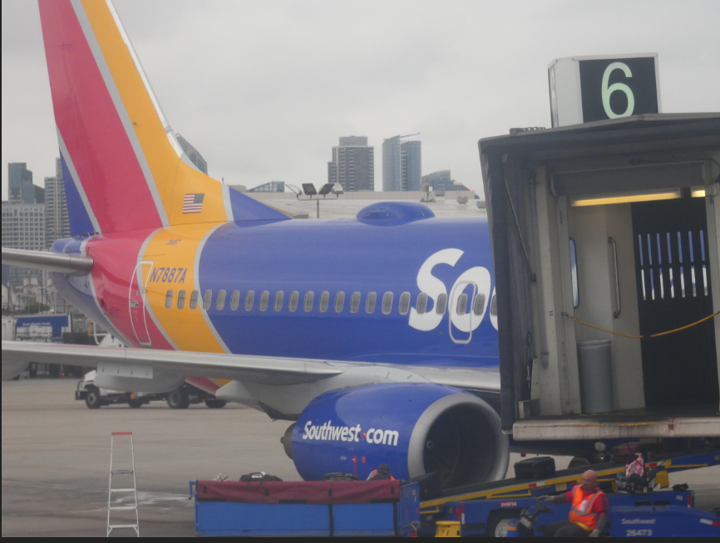
My flight from San Diego left almost an hour earlier than my parent’s flight from Orange County’s John Wayne Airport, so I was already through the security checks when I got a call from my mom that they were running late. There had been a mix-up with the airport shuttle, and now my sister’s husband would be driving them to the airport. I had just enough time to call my wife to warn her of their travel issue before having to board my plane, where I would be subjected to phone call and text silence for the duration of my flight to Las Vegas.
Satellite antenna dome on SW aircraft

Southwest now offers Wi-Fi on all their flights for $8 per day (all flight segments on your trip). You can see the little domes on the top of the plane’s fuselage just ahead of the tail, where the satellite antenna resides. I normally would not buy Wi-Fi, but since I saw email as my only hope for finding out while in flight if my parents got on their plane, I bought it. It also helped to know I would also be allowed to use it on the Las Vegas to Omaha flight. While in flight, I was able to communicate with my wife through email (web mail on my phone), and she relayed to me that my brother-in-law had dropped them off in time, but there was no way to know if they got on the plane before it left. I was in a rush to make the connection and get information, so I didn’t try my VPN service (Private Internet Access) with Southwest’s Wi-Fi.
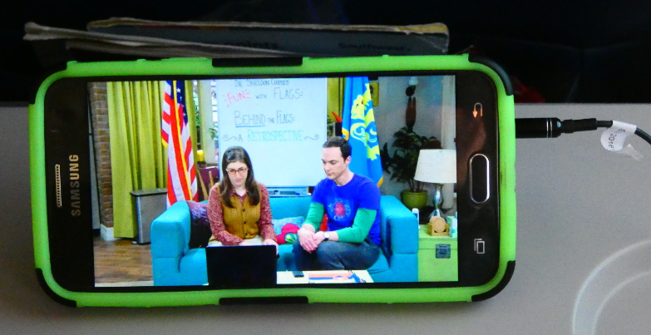
Free TV on Your Device Provided by Southwest
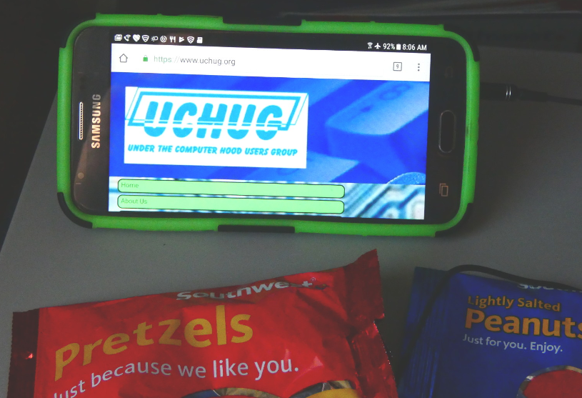
It was while playing with the Southwest Wi-Fi that I realized that the smart phone is the best multimedia device to use in the crowded confines of the airplane. Passengers can use smart phones and tablets at any time during the flight (while in airplane mode) if they are hand-held. Laptops that weight 2 lbs or more (my Chromebook is 2 lbs 6 oz) must be stowed while the plane is below 10,000 ft, presumably because they are large and need to have the tray table lowered to use them.
UCHUG Web Site Viewed Through Southwest Wi-Fi

When I arrived in Las Vegas, I asked if my parents made their flight, but due to security, Southwest could not tell me. I had to wait at their flight’s arrival gate to see if they came off the plane. Fortunately, they did. The second leg the trip was uneventful, except that the Wi-Fi was broken on that plane, so I didn’t get as much as anticipated for my $8 Wi-Fi fee.

I found my VPN worked fine with the hotel Wi-Fi in Omaha for the one night we stayed there but did not work at the hotel in Hastings where we spent most of the trip. The VPN would engage, but when I tried going to a web site, it would time out or churn continuously. With the VPN switched off, I could connect fine in Hastings. I found the Wi-Fi was much faster in the more expensive hotel we stayed at in Hastings; it was 10.02 Mbps down and 30.26 Mbps up, as compared to 3.53 Mbps down / 1.45 Mbps up in Omaha.

My TeamViewer connection plan worked great in both hotels. I was able to use my Chromebook to connect to and show the desktop of my Windows 7 laptop at home. There was a slight lag in operation, but for the most part I could do anything on the laptop that I could do if I was in front of it, including emails, file access and printing - even freak out my wife remotely. She has a network printer sitting next to her in her home office; when I created a document that said I missed her and printed it there (unexpectedly for her), she didn’t appreciate it as much as I would have thought.

I used Google Maps on my smart phone for navigation on this trip, which again worked fine in urban areas, but fell flat in much of the state that is rural, due to the lack of cell coverage. Fortunately, my knowledge of Nebraska state geography and the paper AAA state map I brought got us through to our destinations.

With my TeamViewer travel experiment a success, I can now carry my entire home network with me in my Chromebook case, so to speak. If I have good internet access, I should be able to do anything on the computer that I can do at home. I wonder if my poor laptop will ever get to travel again?

Photos credit Greg Skalka


